Supplemental Appendix 1. World Health Organization Dehydration Assessment Algorithm

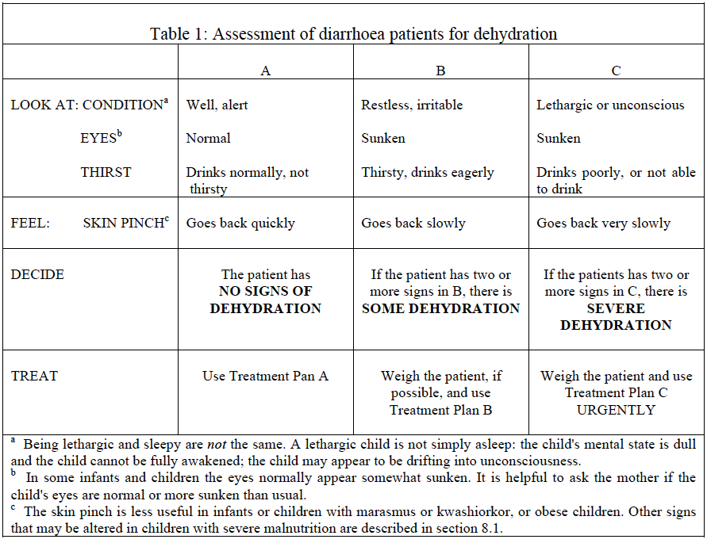

Text in column A, “TREAT” row should read “Use Treatment Plan A”.
Source: World Health Organization (WHO). The treatment of diarrhoea: A manual for physicians and other senior health workers. Geneva: WHO; 2005.

